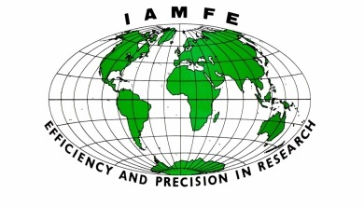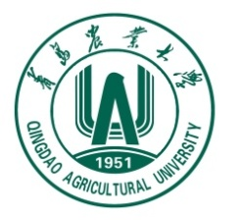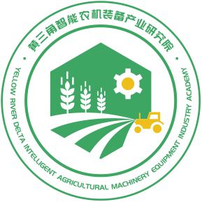
IAMFE/Egypt’2026
Announcement of The 17th International Conference and Exhibition on Mechanization of Field Experiments
September 20-23, 2026 Cairo, Egypt
I Sponsor
International Association on Mechanization of Field Experiments (IAMFE)
II Organizer
Egypt National Research Centre (NRC)
III Co-organizers
Chinese Society of Agricultural Engineering
Qingdao Agricultural University
Yellow River Delta Intelligent Agriculture Machinery Equipment Industry Academy
Qingdao Agricultural Machinery Production and Distribution Association
Qingdao Plantech Mechanical Technology Co., Ltd.
IV Meeting Language
English
V Exhibition
The equipment exhibition of this conference will be held together with The 38th Edition of the International Agricultural Exhibition for Africa and the Middle East (SAHARA Expo 2026). Instruments and equipment covering the entire seed industry chain will be featured, mainly including: field experimental machinery for seed breeding, and production; intelligent and information-based technology products (e.g., digital twins, remote operation, Internet of Things); instruments and equipment in the field of biological breeding; seed processing and comprehensive treatment equipment; testing and measurement equipment for field experiments and laboratory analysis; soil and environmental detection equipment; and poster displays of relevant research achievements in the seed industry.
VI Call for Papers and Topics
- Methods for Field Experiment Management in Seed Breeding and Propagation
- Agricultural Machinery-Agronomy Integration Technology for Crop Breeding
- Mechanization Technology and Equipment for Seed Breeding, Propagation and Production
- Seed Digitalization and Informatization Technology
- Seed Processing, Testing Technology and Equipment
- Smart Agriculture-Related Technology and Equipment
- Technology and Equipment for Seed Breeding, Propagation and Production in Protected Environments
- New Technologies for irrigation and farm machinery
- Other related topics
Abstracts and full papers are accepted in English and shall be published in Conference Proceedings (free in charge) or International Academic Journals. For the format of the paper writing, please refer to the template. Authors willing to publish their papers in international academic journals need to pay an additional fee. Deadlines for paper submission are as shown in the table below:
Item | Deadline
Abstract submission | March 31, 2026
Acceptance Notification | April 30, 2026
Full-paper submission | June 30, 2026
Registration | July 31, 2026
VII Conference registration fee
The conference registration fee for participants is USD 350, for the students is USD 150.
VIII Conference committees
Chair of the Conference Committee:
Prof. Dr. Shang Shuqi
Co-Chair: Prof. Dr. Wafaa Abdel Reheem
Members of the Academic Committee
Chen Xuegeng | Shang Shuqi | Vladislav Minin | Wafaa Abdel Reheem
Wang Yingkuan | Wang Dongwei | Wang Jiasheng | Sun-Ok Chung
Soha Khalil | Zhang Ruoyu | Hani Mehanna | Yang Ranbing
Alexander Bryukhanov | Alexander Aksenov | Myung Kyun Yang | Jaesung Park
Members of the Organizing Committee
Wang Yingkuan | Wang Jiasheng | Du Kun | Hani Mehanna
Tian Yu | Liu Tao | Wang Baochao | Osama Dewdar
Marwa Abdel Baseet | Yang Hao | Li Guoying | Li Yongfan
Ahmed Fares | Farid El Tom | Yang Fan | Zheng Xiaoshuai
IX. Contact Information
Telephone: +86 17660686415; +86 17863907332；
E-mail: yf1762773980@163.com; liyongfan@qau.edu.cn

